Marine Corps Air Station New River
Victim Witness Assistance Council
Organization | Name | Phone number | Billet |  | Unit Address
Installation Victim Witness Liaison Officer / SJA | Mr. William Yables Jr. | (910) 449-7159 | Paralegal Specialist |  | Staff Judge Advocate  Bldg AS-216 PSC Box 21002 Jacksonville, NC 28545
 | Maj Kevin L. Hoffman | (910) 449-7156 | Staff Judge Advocate
Chaplain | CDR Patrick W. Smith | (910) 449-6801 | Station Chaplain |  | Chaplain  Bldg AS-236 PSC Box 21002 Jacksonville, NC 28545
Law Enforcement | Invest. Vasco R. Sutton | (910) 449-6193 | Investigations Officer |  | CID, Bldg AS-302 MCAS New River  Jacksonville, NC 28545
 | Ms. Sandra Barrow | (910) 449-6012 | Special Agent |  | NCIS  Bldg AS-302 MCAS New River  Jacksonville, NC 28545
Legal Services Support Section | Mrs. Carly H. Rivera-Del-Valle | (910) 450-7111 | Victim Witness Coordinator |  | LSST-East  Bldg 63  PSC BOX 20005  Camp Lejeune, NC 28542
Marine and Family Services | Ms. Katherine Light | (910) 449-6110 | Victim Advocate |  | Marine and Family Services Bldg AS-90, MCAS New River Jacksonville, NC 28545
 | Ms. Mika Haberlin-Sleppy | (910) 449-5243  24/7 hotline:  (910) 750-5852 | Installation  SAPRC
Medical | HM1 Shannon P. Thompson | (910) 449-6500  X292 | LCPO |  | Medical  Bldg AS-100  MCAS New River  Jacksonville, NC 28545
Equal Opportunity Advisor | CWO2 Matthew J. Roby | (910) 449-7332 | IPAC Outbound OIC |  | Headquarters & Headquarters Squadron PSC BOX 21002 Jacksonville, NC 28545
 | SSgt Erika M. Cruz | (910) 449-4411 | Postal Chief
Victim Witness Assistance Coordinators & Council members

Unit | Name | Phone number | Billet | Unit Address
H&HS | Mr. Mark Buechner | (910) 449-7151 | Legal Officer | Headquarters & Headquarters Squadron PSC BOX 21002 Jacksonville, NC 28545
CNATT | SSgt Nick T. Weeden | (910) 449-5327 | Adjutant | CNATT MARU  New River PSC Box 21036 Jacksonville, NC 28545
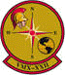  VMX-1 | SSgt Michael V. Farina | (910) 449-4129 | Legal Officer | Marine Tiltrotor Test and Evaluation Squadron PSC Box 21037 Jacksonville, NC 28545
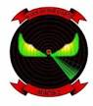  MACS-2 | SSgt. Daniel J. Biggs | (910) 449-7414 | Legal Officer | Marine Air Control Squadron 2  Marine Air Control Group 28  PSC Box 21007  Jacksonville, NC 28545

Victim Witness Assistance Coordinators & Council members

Unit | Name | Phone number | Billet | Unit Address
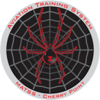  MATSS | Please contact the  VWAC for  MAG-29 |  |  | Marine Aviation Training System  PO Box 21035  Jacksonville, NC 28545
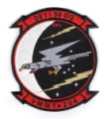  58th OprGrp Det1 | Please contact the  VWAC for  VMMT-204 |  |  | 58th Operations Group Detachment 1  PSC Box 4420  Jacksonville, NC 28545
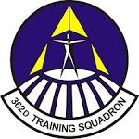  362 TRS DET1 | Please contact the  VWAC for CNATT |  |  | Air Education and Training Command  362 Training Squadron  Operation Location “A”  Jacksonville, NC 28545
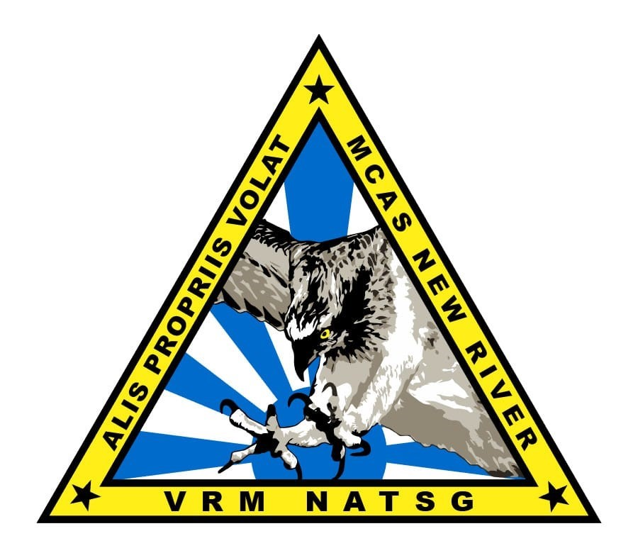  NATSG | LT Gerald Ramir S. Rivera | (910) 449-5224 | Legal Officer | Naval Aviation Training Support Group New River  PSC BOX 21039  Jacksonville, NC 28545
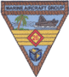  MAG 26 | 1stLt Megan K. Gleason | (910) 449-6128 | Legal Officer | Marine Aircraft Group 26 PSC Box 21010 Jacksonville, NC 28545
MALS-26 | GySgt Christopher E. Keagy | (910) 449-7931 | Production Control SNCOIC | Marine Aviation Logistics Squadron 26  PSC Box 21011 Jacksonville, NC 28545
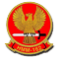  VMM-162 | Capt Jeffrey A. Waits | (910) 449-5378 | Adjutant | Marine Medium Tiltrotor Squadron 162 PSC Box 21024 Jacksonville, NC 28545
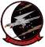  VMMT-204 | 2ndLt Zerek D. Olson | (910) 449-5051 | Legal Officer | Marine Medium Tiltrotor Training Squadron 204 PSC Box 21018 Jacksonville, NC 28545
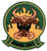  VMM-261 | 1stLt David A. Butler | (910) 449-7105 | Legal Officer | Marine Medium Tiltrotor Squadron 261 PSC Box 21015 Jacksonville, NC 28545
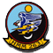  VMM-263 | 1stLt Michael B. Landry | (910) 449-5951 | Adjutant | Marine Medium Tiltrotor Squadron 263 PSC Box 21025 Jacksonville, NC 28545

Victim Witness Assistance Coordinators & Council members

Unit | Name | Phone number | Billet | Duty Address
VMM-266 | 1stLt Nicholas G. Weddle | (910) 449-6302 | Adjutant | Marine Medium Tiltrotor Squadron 266 PSC Box 21017 Jacksonville, NC 28545
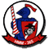  VMM-365 | 1stLt Michael J. Kenyon | (910) 449-6550 | Adjutant | Marine Medium Tiltrotor Squadron 365 PSC Box 21026 Jacksonville, NC 28545
MWSS 272 | 2ndLt Kevin Byington | (910) 449-7460 | Adjutant | Marine Wing Support Squadron 272  PSC Box 21032 Jacksonville, NC 28545
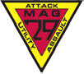  MAG 29 | CWO2 Bryan J. Liciagarecci | (910) 449-6567 | Personnel Officer | Marine Aircraft Group 29 PSC Box 21020 Jacksonville, NC 28545
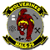  MALS-29 | GySgt Benjamin M. Gibbons | (910) 449-7051 | Legal Chief | Marine Aviation Logistics Squadron 29  PSC Box 21002 Jacksonville, NC 28545
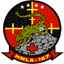  HMLA-167 | Capt Gavin F. Hermanson | (910) 449-5934 | Legal Officer | Marine Light/Attack Helicopter Squadron 167 PSC Box 21014 Jacksonville, NC 28545
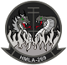  HMLA-269 | Capt William L. Martin | (910) 449-6914 | Legal Officer | Marine Light/Attack Helicopter Squadron 269 PSC Box 21022 Jacksonville, NC 28545
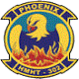  HMHT-302 | Capt Jonathan D. Grizzle | (910) 449-6184 | Legal Officer | Marine Heavy Helicopter Training Squadron 302 PSC Box 21008 Jacksonville, NC 28545
HMH-461 | 1stLt Brenna L. McDannold | (910) 449-6548 | Legal Officer | Marine Heavy Helicopter Squadron 461 PSC Box 21013 Jacksonville, NC 28545
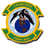  HMH-464 | 1stLt Tyler S. Hardenbrook | (910) 449-5185 | Adjutant | Marine Heavy Helicopter Squadron 464 PSC Box 21023 Jacksonville, NC 28545
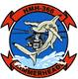  HMM-366 | Capt Preston E. Green | (910) 449-5511 | Legal Officer | Marine Heavy Helicopter  Squadron 366  PSC Box 21019  Jacksonville, NC 28545

